

| **Title:** Implementation of Database in SQL -DDL |
| --- |



**Objective:** Define/modify database definitions with proper constraints



**Expected Outcome of Experiment:**

CO 2: Convert entity-relationship diagrams into relational tables, populate a relational

database and formulate SQL queries on the data Use SQL for creation and query the database.

CO 3: Define and apply integrity constraints and improve database design using normalization techniques.



**Books/ Journals/ Websites referred:**

1. Sharaman Shah,”*Oracle for Professional*”, SPD.
2. Dr. P.S. Deshpande, SQL and PL/SQL for Oracle 10g.Black book, Dreamtech Press
3. Korth, Slberchatz, Sudarshan: “Database Systems Concept”, 5th Edition , McGraw Hill
4. Peter Rob and Carlos Coronel,”Database Systems Design, Implementation and Management”, Thompson Learning, 5th Edition

**Pre Lab/ Prior Concepts**:

Resources used: Postgresql

**Theory:** The set of relations in a database must be specifies to the system by means of a data definition language (DDL). The SQL DDL allows specification of not only a set of relations but also specific information about the relation including,

1. The schema for each relation
2. The domain of values associated with each attribute
3. The integrity constraints
4. The set of indices to be maintained for each relation
5. The security and authorization information for each relation
6. The physical storage structure of each relation on disk

# Syntax Create Table:

# create table employee(ssn,fname varchar(10), mname varchar(10), lname varchar(10), desg varchar(20), gender varchar(5), addr varchar(20), bdate datetime, sal float,primary key(ssn));

create table manages(ssn int, dept_code int, start_dt datetime, foreign key(ssn)

create table manages(ssn int, dept_code int, start_dt datetime, foreign key(ssn)

references employee, foreign key(dept_code) refrences department, key(ssn,dept_code) ) on delete set null;primary

# Data Constraints

Busines managers of the organization determine the a set of rules that must be applied before the data is stored in the database. The application of such rules on raw data ensures **data integrity**.

**Eg:-** An employee belonging to Sales department cannot have salary higher than Rs. 1000.

An employee has an unique identification number.

# Applying Data Constraints

Oracle permits data constraints to be attached to table columns using SQL syntax. Constraints can be attached to table columns using

Alter table

# Unique Constraint

**Unique Constraint- At column level Syntax**

**<ColumnName><Datatype>(<size>)**

**UNIQUE Unique Constraint- At table level**

**CREATE TABLE<TableName>(**

**<ColumnName><Datatype>(<size>)**

**<ColumnName><Datatype>(<size>)**

**<Columnname><Datatype>(<size>) UNIQUE(<ColumnName1>,<ColumnName2>);**

**Implementation Details (Problem Statement, Query and Screenshots of Results):**

create table Users(

userId int primary key,

email varchar NOT NULL,

username varchar NOT NULL,

hashPass varchar NOT NULL

);

create table Blogs(

blogID int,

userId int,

title varchar NOT NULL,

contents varchar NOT NULL,

blogType varchar NOT NULL,

primary key(blogID, userID)

);

create table UserComments(

commentID int,

contents varchar NOT NULL,

userId int,

blogID int,

primary key(commentID,userID,blogID)

);

create table Roles(

roleId int,

userId int,

roleName varchar NOT NULL,

roleDescription varchar,

primary key(roleId, userID)

);

-- drop table Users;

-- drop table Blogs;

-- drop table UserComments;

-- drop table Roles;

alter table UserComments add constraint fkey1 foreign key(userID) references Users(userID);

alter table UserComments add constraint fkey2 foreign key(blogID) references Blogs(blogID);

alter table Roles add constraint fkey3 foreign key(userID) references Users(userID);

alter table Blogs add constraint fkey4 foreign key(userID) references Users(userID);

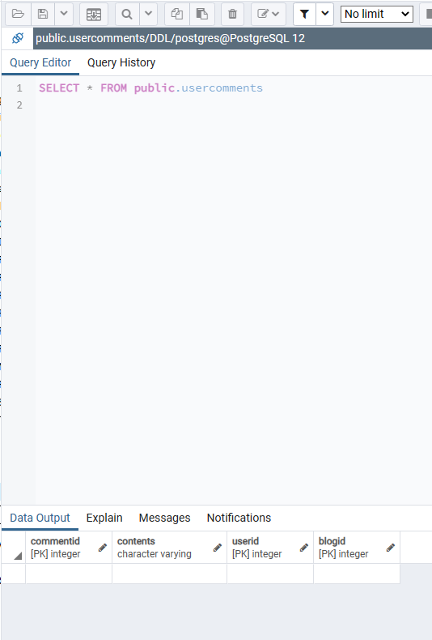

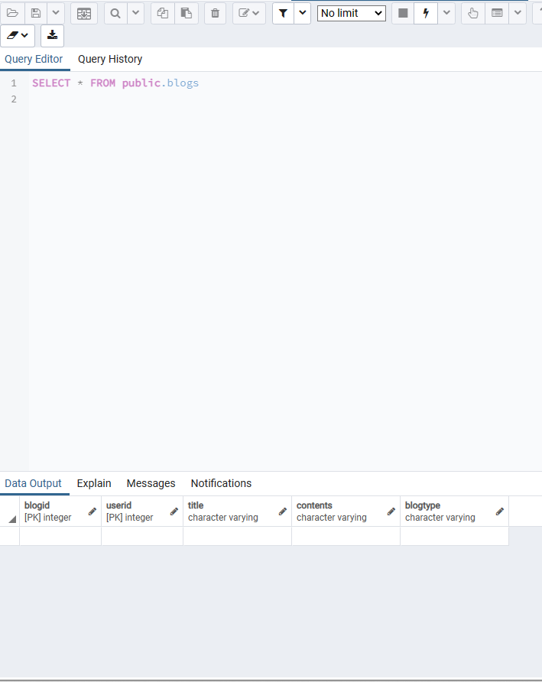

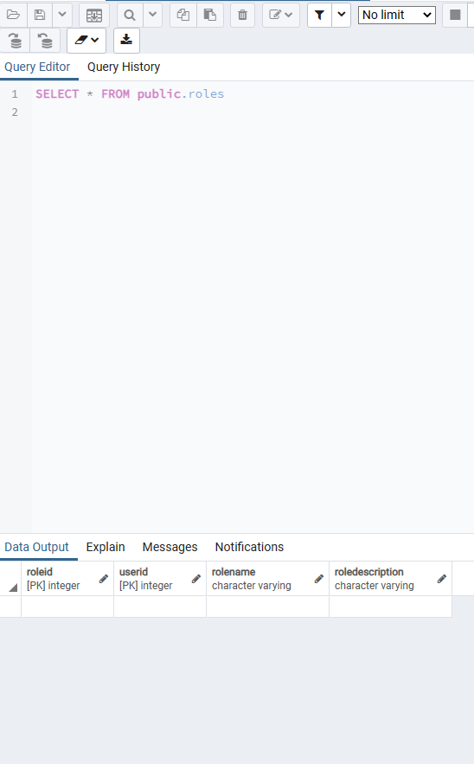

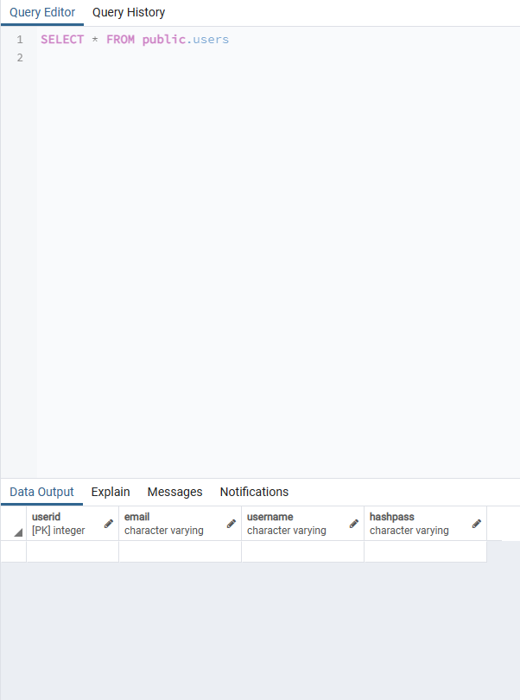

# Conclusion:

Successfully Created tables using pgadmin.

# Post Lab Questions:

# Which command is used for removing a table and all its data from the database:

# DROP Command

# TRUNCATE Command

# Both Commands

# For the given ER model, using DDL command: Write syntax to create CREATE Tables with all possible integrity constraints

# Problem Statement:

# A small accounting firm wants a simple HR application that will help it to keep track of its employees, their positions, allowances, salary scales, and which company vehicles their employees drive. The application must keep track of all the positions at the firm, the employees filling these positions, the allowances for these positions, the salary scales for these positions, and the company vehicles assigned to these positions.

# Case Study 1 detailed E-R diagram

CREATE TABLE position (

position_id INT PRIMARY KEY,

position_title VARCHAR(50) NOT NULL,

salary_scale DECIMAL(10,2) NOT NULL,

UNIQUE(position_title)

);

CREATE TABLE employee (

employee_id INT PRIMARY KEY,

first_name VARCHAR(50) NOT NULL,

last_name VARCHAR(50) NOT NULL,

position_id INT NOT NULL,

FOREIGN KEY (position_id) REFERENCES position(position_id) ON UPDATE CASCADE ON DELETE RESTRICT

);

CREATE TABLE allowance (

allowance_id INT PRIMARY KEY,

allowance_name VARCHAR(50) NOT NULL,

allowance_amount DECIMAL(10,2) NOT NULL,

UNIQUE(allowance_name)

);

CREATE TABLE employee_allowance (

employee_id INT NOT NULL,

allowance_id INT NOT NULL,

amount DECIMAL(10,2) NOT NULL,

PRIMARY KEY (employee_id, allowance_id),

FOREIGN KEY (employee_id) REFERENCES employee(employee_id) ON UPDATE CASCADE ON DELETE CASCADE,

FOREIGN KEY (allowance_id) REFERENCES allowance(allowance_id) ON UPDATE CASCADE ON DELETE CASCADE

);

CREATE TABLE vehicle (

vehicle_id INT PRIMARY KEY,

make VARCHAR(50) NOT NULL,

model VARCHAR(50) NOT NULL,

year INT NOT NULL

);

CREATE TABLE position_vehicle (

position_id INT NOT NULL,

vehicle_id INT NOT NULL,

PRIMARY KEY (position_id, vehicle_id),

FOREIGN KEY (position_id) REFERENCES position(position_id) ON UPDATE CASCADE ON DELETE CASCADE,

FOREIGN KEY (vehicle_id) REFERENCES vehicle(vehicle_id) ON UPDATE CASCADE ON DELETE CASCADE

);